Version 2.1 March 2023
Miniature Aircraft Society of Truro | 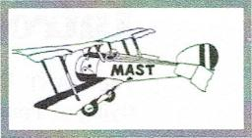

WINGS PROGRAM
Introduction 1
Indemnity 1
Instructor 1
Student 2
Trainer Aircraft 2
Radio System 4
Learning Process 5
Ground School 5
The Trainer 5
The Axis 6
The Forces 6
Lift 7
Stall 7
The Transmitter 7
Effects of Control Surfaces 8
Safety 11
Flight School 11
Training Schedule 12
1st Phase - Preparatory 12
2nd Phase-Working Together 12
3rd Phase - Basic Flying Skills 13
4th Phase - Intermediate Skills 13
5th Phase - Taking Off 14
6th Phase - Landing 14
7th Phase - Prep for Solo 14
Flight Test 15

Introduction
1
The MAST Wings Program provides the guidelines to achieve initial proficiency in the safe flying of a radio-controlled model aircraft. There are no charges or fees.
To participate in the Wings Program, you must be a current member of the Model Aeronautics Association of Canada, or MAAC, the organization which governs operation of radio control model aircraft in Canada and provides you with the necessary insurance.
To obtain MAAC membership, you can send in the Membership Application form to M.A.A.C. 5100 South Service Road West, Unit #9, Burlington, Ontario L7L 6A5, or log onto the MAAC website: maac.ca, then Join MAAC and select New Member — Join MAAC.
You must also be a member of MAST. This requirement may be waived if you live a considerable distance from our flying field - George Lacey Field. MAST does not provide a model airplane trainer.
This Wings Program manual is not intended as an all-encompassing technical source for radio-controlled model aircraft - it does include such aspects as selecting a trainer„ engine or motor, radio system, principles of flight, control, and training schedule.
Indemnity
A possible aspect of the hobby is that your model aircraft may crash due to component failure or pilot error. Selecting a qualified instructor, an appropriate trainer aircraft, and using a "buddy box", will minimize the chance of a crash.
You must agree the MAST and/or the Instructor will be blameless in the event of any or all accidents resulting in damage to or loss of your model or property, regardless of whether the aircraft was under the control of yourself or an instructor at the time of the accident.
If you are UNWILLING to agree to the above indemnity release then you CANNOT undergo flight training with MAST.
Instructor
Selection of your instructor is important. You have two viable choices: a MAST designated instructor or a member of MAST who you feel has the necessary flying experience.
A MAST designated Instructor will ensure that you will learn all the right knowledge and skills in a progressive and rewarding manner and promote safety, and is the better choice. The second choice may apply when an instructor is not present.
Communications between yourself and the Instructor is important. The student is required to take the initiative in having the Instructor on hand when you are available and be willing to fly as often as you can.

Student
2
Our Wings Program works - if you the student pilot, are willing to read, observe, and learn the necessary technical and operational knowledge, and understand the importance of safety.
The Wings Program works - if you devote sufficient time in accumulating the necessary piloting skills
As a student pilot — you will not fly at George Lacey Field by yourself.
You will only fly if assisted by an instructor or experienced pilot.
When you successfully pass the Flight Test you can then fly on your own.
Trainer Aircraft
Selecting an appropriate trainer is an important step in learning to fly model aircraft. You will need a plane which is specifically designed as a trainer. There are certain criteria that a trainer should have in order to be satisfactory for a beginner.
- High Wing - A high wing model is inherently more stable than a
low wing model due to pendulum effect. Since the weight of the model is below the wing, the fuselage tends to swing downward like a pendulum in order to equalize forces.
- Wing Mounting - The wing should be held on the fuselage by rubber bands, so that in the case of a hard landing or crash, the damage to the wing is minimal.
- Flat Bottom Wing – The wing cross section should have virtually flat bottom. This has gentler flight characteristics.
- Dihedral - The wing should have some dihedral. This means that the tips of the wings are higher than the center. The effect of the dihedral is to try to equalize forces and keep the wings level and return the wings to a level orientation.
- High Aspect Ratio - The ratio of the wing length or span should be at least 5 ¹/₂ times the width or chord. This will reduce the rate at which the model responds to command input allowing more time to react.
- Constant Chord - The width of the wing should be the same from the center or root to the end or tip. This distributes the weight of the airplane evenly over the entire surface of the wing.
- Low Wing Loading - The weight of the model divided by the area of the wing should not exceed 19 oz./sq. ft. This reduces the speed required to maintain an acceptable rate that the model descends when the power is reduced resulting in a lower landing speed.
- Moderate Size — The wing span should be in the 60-inch range. A smaller one is more susceptible to the effects of wind and difficult to see. A larger size is easier to fly in the wind and easier to see but is more difficult to transport.

- Structurally Sound - A trainer must be able to take the abuses imposed by beginner. This is especially true for hard landings. It must be able to withstand minor crashes with minimal damage. It should be relatively easy to repair.
- Control Surfaces - It is advisable that the trainer include aileron, elevator, rudder, and throttle.
Worst case scenario is a small 3-channel "foamy", complete with motor and transmitter. Cheap — yes. Viable — no. Likely only good on rare calm days, lacks ailerons, difficult ground handling, and flits around the sky.
Another worst-case scenario is trying to learn to fly a scale "war bird", complete with retractable landing gear. Lots of "eye candy" appeal but expensive and designed for experienced pilots. Very heart breaking when it crashes.
Avoid highly aerobatic models — again designed for experienced pilots, and rarely successful when used as an initial trainer.

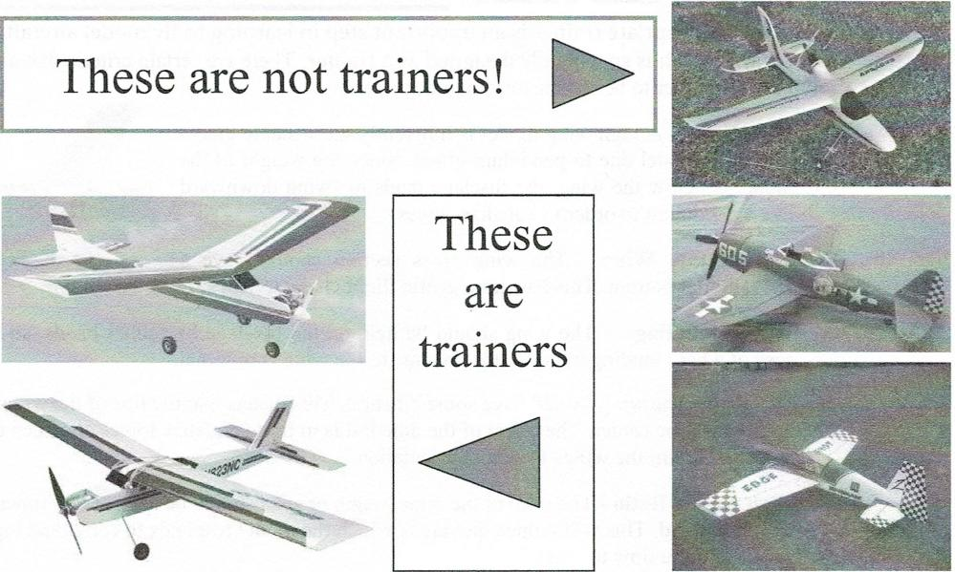
These are not trainers!
-
- ⁻"Oinatia
^{.4}•01_{kiiiivarvw}

Kit or ARF? At one time newcomers to the hobby built their trainer from a kit. The advantage is it gives the builder the pleasure of building, the option of color and trim scheme, and the knowledge of the structure if repairs are required. The biggest disadvantage is the time required to construct the model, or lacking the necessary skills, when the beginner would rather be learning to fly.
3
The big advantage of the ARF (Almost Ready to Fly) models is that they can be assembled in a matter of a few hours and the beginner can be ready to start his/her flying lessons. Some model manufacturers offer a bundled deal, which includes the trainer, engine or motor, and radio system.

4
Glow Engine or Electric Motor? Yes, another dilemma.  Glow engines appeal to those that are mechanically inclined and like the noise. Glow fuel is a mixture of methanol, nitromethane, and castor oil which can be expensive if you plan on doing a lot of flying. A field box to hold fuel, battery and electric starter, glow plug igniter, and tools, is required. The down side is 2-cycle glow engines are susceptible to changes in air pressure, and leave castor oil all over the airplane. | 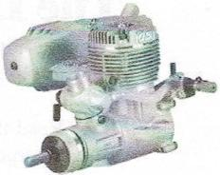

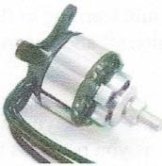 | Brushless electric motors and rechargeable Lithium Polymer batteries are the trend. The advantages are: efficiency, clean, all seasonal, and quiet, to name a few. The down side is time in the air — sometimes half that of glow engines. The over-all cost is comparable with glow engines, considering all the support accessories and fuel required for glow engines.

Seek advice when considering which trainer to buy. Regardless of the amount of advice that the beginner gets from experienced modelers and reputable hobby suppliers, the final decision is the beginners. The choice of a model is an individual choice and all the pros and cons must be weighed
Radio System
There are many varieties of radios for model airplanes ranging from very simple to very complex, the more complex the system is, the more expensive its going to be. There is no point in breaking the bank to get a radio with all the bells and whistles if you don't need them or can't use them with the trainer you plan to fly. On the other hand, you don't want to buy a radio that will not meet future needs.
In the past, radio systems were dedicated to a single model and used the 72 MHz band. Today the right choice is a spread spectrum multi-model system that operates in the 2.4 GHz band. These systems are available starting with a 4  channel transmitter, to over 10 channels. The number of channels required  relate to the number of motor/engine and control surfaces. A trainer requires a minimum of 4 channels to control the throttle, aileron, elevator, and rudder. In the future you may require more channels, such as flaps and landing gear.  The common brands are: Futaba, JR. Hitec, and Spektrum. | 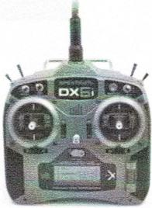

Different clubs favor particular brands. Many MAST members are currently Spektrum users, and their combined experience in the use of, programming, and the availability of "buddy boxes", gives the newcomer an advantage. The second choice of brands would be Futaba.
It is suggested that you invest in a 2.4 MHz radio that can control at least 6 channels and
capable of selecting 10 or more individual models, such as the Spectrum DX6 system.

- Read the MAST RPAS Ops Manual which contains the rules for flight operations at George Lacey Field. The contents may be obscure at first but will become apparent as you accumulate operational rules, technical knowledge, and flying skills.
The Learning Process
Learning how to fly requires reading, observing, asking questions, and being on hand to fly as much as possible. Normally the student pilot is given priority-take advantage of it!
- You are not required to have an in-depth understanding of flight while learning to fly. You are advised to learn the essentials required to properly maintain your aircraft and ensure consistent flight characteristics.
- Follow the Training Schedule. This schedule has been designed to assist you in acquiring skills in a progressive sequence. Your instructor will evaluate you as you progress through the schedule.
- Self-evaluate your progress, pay attention to your instructor's comments and suggestions, and avoid learning bad or unsafe habits.
In essence, you will train your reflexes, or "thumbs", and this takes practice. Welcome to the enjoyable hobby of R/C model aircraft.
Ground School

The trainer...

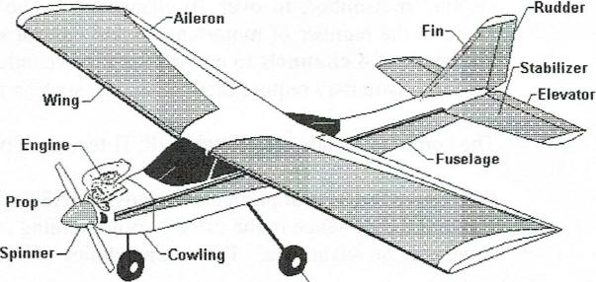
Wing
Engine
Prop
Spinner
Stabilizer
Elevator
Shown is a trainer model powered by a 2-cycle glow engine.
It could be electric if using a brushless motor.
5
The axis...

Yaw Axis

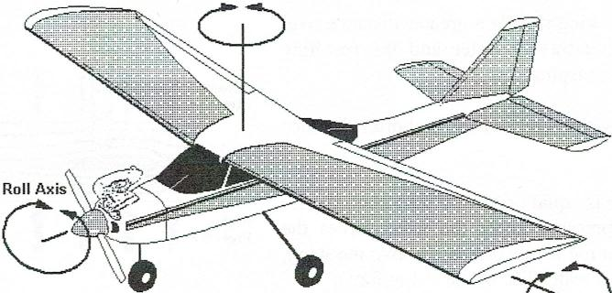 | Each axis of flight is an imaginary line around which an airplane can turn.  Think of an airplane rotating around an axis like a wheel rotates around an axle.

Pitch Axis
The PITCH or lateral axis runs from wing tip to wing tip. The aircraft pitches, noses up or down, around this axis, and is controlled by the elevator.
The ROLL or longitudinal axis runs from the nose of the aircraft to the tail. This is the axis around which the aircraft rolls - rotates left or right, and is controlled by the ailerons.
The YAWL or vertical axis is slightly different to the others, running vertically through the center of the aircraft. The aircraft yaws, turns left or right, around this axis, and controlled by the rudder.
The forces... Before the  control aspects are explained, the forces on an aircraft in flight should be appreciated.  - The engine or motor provides the THRUST (propulsion)  - As the plane flies through the air, there is resistance — called DRAG. | 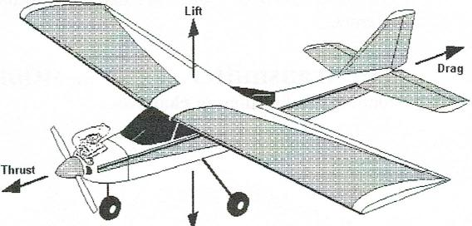

Weight
THRUST must be equal or greater than the DRAG. |  | Flight Forces

- The wing has a particular shape which provides LIFT, and forces the plane to rise.
- The WEIGHT of the plane causes the airplane to drop due to gravity.
LIFT must be equal or greater than WEIGHT
6

Lift... The wing creates the lift — the force which causes the airplane to rise. As the airplane moves through the air, the airstream divides and flows both over and under the wing.
Air flowing about the wing travels a greater distance over the wing and therefore travels faster and the resulting pressure is less than atmospheric pressure.
Lift
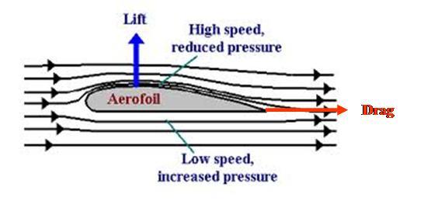
The air flowing below the wing travels a shorter distance and travels slower.
The resulting pressure is equal or greater than atmospheric pressure. The higher pressure under the wing forces the wing upwards towards the lower pressure above the wing, creating lift. The wing creates lift, or the rising force.

If there is no air flowing past the wing then there is no lift. The faster the plane moves through the

air — the greater the life.
Normally, in level flight, the angle of attack is positive — the leading edge is higher than the trailing edge.
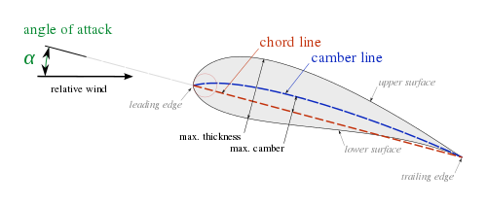
If the plane pitches up, or climbs, the air moving about the wing because less and the lift decreases.

Stall... If the plane pitches up too high, all the airflow will flow under the wing, lift is then
lost. This is known as stall. As there is no lift — the airplane will stop flying! A stall will also occur if the airspeed of the airplane is too slow.
For those interested - there are numerous technical articles relating to the principles of lift on the internet,
The transmitter... We use MODE II in which there are two sticks, and each stick controls two functions or channels.

The left stick controls the throttle (up or down) and rudder (left or right). The rudder movement is spring loaded — if released it will return to the center or neutral position. The throttle movement is not spring loaded and will remain in position when released.

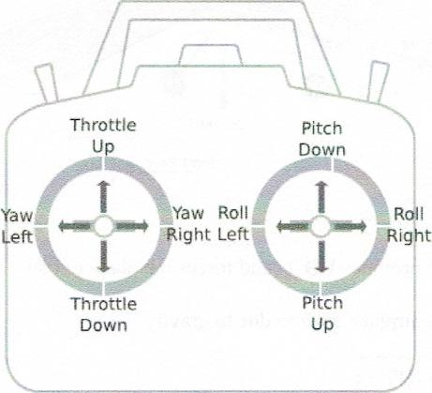
ThrotVe
Down
Pitch Up
7
The right stick controls the elevator (up or down) and aileron(left or right). Both are spring loaded and will return to the center position when released.
The transmitter continuously encodes (converts) the position of each channel and sends them to the receiver in the airplane,

which then decodes each channel and causes the servos to correspond to the transmitter. These servos in turn control the throttle level and the position of the three control surfaces: aileron, elevator, and rudder. In the case of an electric airplane there is no throttle servo — the throttle channel is connected electrically to the motor controller.

A beginner must know the effect that a stick movement has on the airplane
Throttle ... The throttle stick is located on the left. Before takeoff or

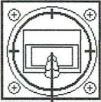
Throttle at IDLE
once landed, this stick is down in the idle position,
Moving the throttle stick up will increase the revolutions of the propeller and the airplane will fly faster. When fully up the engine or motor is at full throttle.

If the throttle stick is in the up position and moved down, the revolutions of the prop will decrease, and the airplane will fly slower.
During normal flight, the throttle is set so that a comfortable flying speed is maintained. This means that thrust is equal to drag and lift is equal to weight. From this stable condition, the effects that the stick movements
Rudder ...The rudder stick is also on the left of the transmitter, controls the yaw of the airplane.
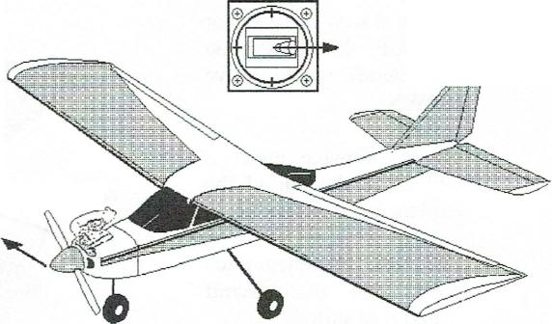
If moved to the right, the rudder moves to the right, and the air hitting the deflected rudder will cause the tail of the airplane to yawl to the right, and Nose moves right the plane will then turn right.
Rudder moves right

Left Stick - Move Right

Nose moves left
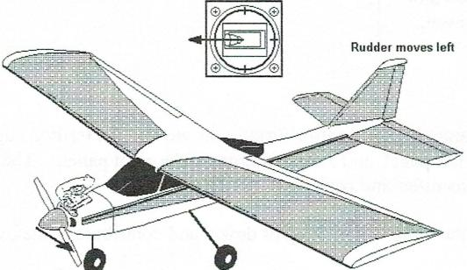
Rudder moves left
8
Left Stick -MoveLeft

Left Stick - Move Left

If moved to the left, the rudder moves to the left, and the air hitting the deflected rudder will cause the tail of the airplane to yawl to the left, and the plane will then turn left.

The rudder stick is spring loaded and will return to neutral when released.

Elevator... The elevator stick is located on the right of the transmitter and controls the pitch
(up or down) axis of the airplane.
When the right stick on the transmitter is moved DOWN, the airplane pitches UP.

Right Stick - Pull Back

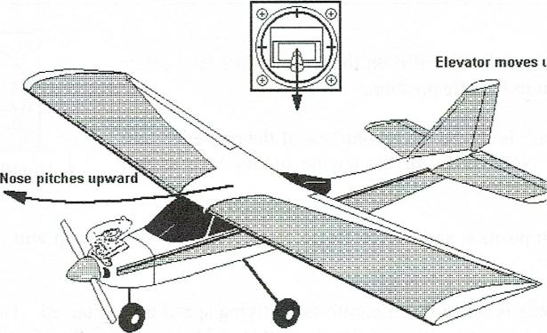
Elevator moves t
Nose pitches upward
This initially seems to be backwards but it is not.
When the elevator is moved up, the air flowing over it will cause the tail of the airplane to be pushed down.
The result is that the nose of the aircraft is then pitched up, and gains altitude.

If you moved the elevator stick UP, the elevator on the aircraft would move DOWN.
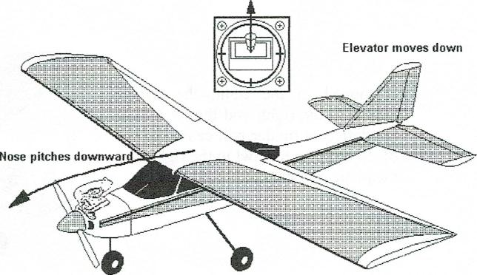
Elevator moves down
Nose pitches downward
The air flowing under it will cause the tail of the airplane to be pushed up.
The nose will then pitch down and the aircraft would lose altitude.

9
Right Stick - Push Forward
The elevator stick is spring loaded and will return to neutral when released.

Ailerons... There are two separate aileron control surfaces located on the trailing edge of the wing. There is a left aileron on the left panel, and a right aileron on the right panel. The aileron stick is located on the right of the transmitter and controls the roll axis.
Normally the ailerons are level with the wing — neither up or down, and contribute to the over-all lift of the wing.

When the aileron stick is moved, the two aileron surfaces move in opposite directions to each other, this causes one aileron to increase the lift, and the other to decrease the lift (drag).
When an aileron surface moves up it causes drag — the lift on that wing panel is reduced, and conversely, when a aileron surface moves down, the lift on that wing panel is increased.
The drag will push that wing panel down and the lift on the opposite panel will be pushed up. The over-all effect is that the airplane will roll.

If the aileron stick is moved RIGHT, the right aileron moves up and the left aileron moves down.

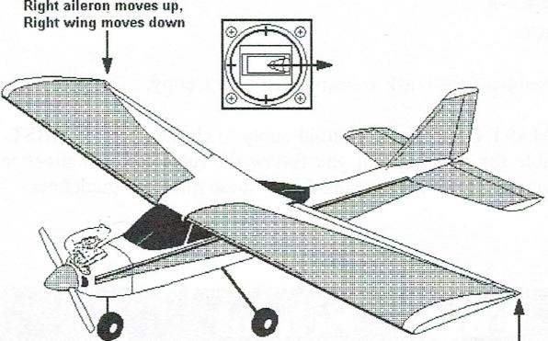
Right aileron moves up.
Right wing moves down
Left aileron moves down,
Right Stick - Move Right Left wing moves up
This causes the airplane to roll to the right, meaning that the left wing moves up and the right wing moves down.
It will continue to roll as long as the stick is held in the same position, and the over-all lift decreases causing to airplane to drop.

If the aileron stick is moved to the LEFT, the left aileron moves up and the right aileron moves down, causing the aircraft to ROLL to the left. Again, when in a roll, the lift decreases and the aircraft will begin to drop.
10
Using the aileron to turn is also called BANKING. A student will learn, when moving the right stick left or right to bank, that he/she will also move the elevator UP slightly to keep the plane level while the aircraft is banking. For example, if banking left, the stick is moved both to the left and slightly down. This is the common method for turning the aircraft. With practice, sharp banks (or turns) with little or no loss of altitude, can be made.
The aileron stick is spring loaded and will return to neutral when released.
Summary of Control Surface Effects .... Again, it is important that you understand the effects that take place when moving the sticks on the transmitter and anticipating what the airplane will do — before you start the learning how to fly.
STICK MOVEMENT CONTROL AXIS EFFECT ON AIRCRAFT
LEFT | UP or DOWN | THROTTLE | PITCH | FASTER or SLOWER
LEFT | LEFT or RIGHT | RUDDER | YAW | TURN LEFT or RIGHT
RIGHT | UP or DOWN | ELEVATOR | PITCH | RISE or DESCEND
RIGHT | LEFT or RIGHT | AILERONS  and ELEVATOR | ROLL | BANK LEFT or RIGHT  and DESCEND
 |  |  | PITCH

Safety Safety Safety
11
Safety is an important aspect of learning to fly. Model airplanes are real, smaller than full scale aircraft, and can be dangerous, especially if handled and flown in an unsafe manner.
Safety is stressed in the following publications:
- MAAC Safety Code
- MAST RPAS Ops Manual
- MAST Wings Program
If you are missing any of these publications — ask your instructor for a copy.
The MAAC Safety Code and MAST RPAS Ops Manual apply to all members of MAST. Initially your instructor will be responsible for ensuring that you follow the rules and guidelines included in these documents, and as you progress, you will learn, and follow these rules and guidelines.
Flight School
A challenging aspect of radio-controlled model aircraft is the never-ending learning curve. Now you can learn to fly. With practice, your "thumbs" will function by reflex, but initially, you will have to firstly think about what you are going to do, i.e., make a left bank, then instruct your right hand to move the right stick of the transmitter to the left, watching how the aircraft reacts, and adjust the deflection on the stick, and likely also having to move it
down to maintain altitude. Much like learning to ride a bike — you will initially be awkward until with practice it becomes and automatic reflex.
Your Instructor will assist you in both the learning and understanding of all the procedures before, during, and after flight sessions.
Communications between the student and instructor is very important, both before, during actual flying, and returning to the pit area.
The instructor has the primary control of the trainer. By pressing a button or operating a switch on the main transmitter, the instructor transfers control to the student's buddy box — the student then has control. He will always inform the student before doing so. The instructor will regain control to prevent a crash, or violation of any safety aspects, or the student tells him to take over.
You may find that the instructor may have to raise his/her voice when you are flying. This is because initially you are so intense and focused on what you are doing.
Hello! Hello! Hello/

TRAINING SCHEDULE
12
The TRAINING SCHEDULE is designed to assist the beginner in learning to fly in a progressive manner. This schedule assists the student pilot in accumulating the necessary knowledge (theoretical or technical aspects) and practicing the required skills (flying by reflex), in a safe and enjoyable way.
In each of the following phases of the TRAINING SCHEDULE, it is recommended that you review the OPERATIONS MANUAL and the appropriate contents of the WINGS PROGRAM.
Good luck.
1st Phase - Preparatory
- Become a member of MAAC
- Become a member of MAST
- Select an instructor
- Obtain your equipment
- Agree to indemnity, in that MAST and the Instructor will be blameless
- Become familiar with the relevant MAAC Safety Codes, as you progress
- Become familiar with the MAST RPAS Ops Manual as you progress
- Follow the WINGS PROGRAM
- Be willing to invest the time in learning to fly
2nd Phase -Working Together
The Instructor and Student start to work together.
- The Instructor encourages the Student to read both the MAAC SAFETY CODE, MAST RPAS Ops Manual, and the WINGS PROGRAM.
- The Instructor carries out an extensive inspection of the Student's airplane and will insist that any problems must be remedied before advancing to the next step.
- The Instructor will demonstrate how to safely start the engine or arm the motor, and then test fly the Student's airplane, including a stall test, which may require returning to Step 2 of this phase.
- The Instructor explains the operation of the transmitter sticks, the corresponding motions of the control surfaces, and the expected action if the plane was in flight.
- The Instructor will take off and then turn control of the aircraft over to the student. It is understood that this being the first flight, the student will likely have problems, in which the Instructor will regain control. The Instructor will then land the airplane and both will discuss the familiarization flight.

3rd Phase - Basic Flying Skills
13
During this phase the Student starts to develop basic flying skills. Flight duration should be short -3 to 5 minutes and as frequent as possible.
- Student carries out PRE-FLIGHT and TAKE-OFF procedures. Instructor does the actual take-off and climbs to a safe altitude (two mistakes high) and demonstrates the desired box pattern.
- Student is then given control and directed to fly a box pattern initially using only left turns but later both left and right turns. Instructor "talks” the Student through each of the 90 degree turns. The Instructor will take control whenever the student falters.
- After a few flights, the Student may be allowed to fly free pattern for a short time.
- Instructor will land.
- Student to practice some ground handling and then return to the pit area.
- Instructor and Student discuss progress and any problems.
4th Phase - Intermediate Flying Skills
In this phase the Student develops additional flying skills. Flight duration can be increased to 5 to 8 minutes and repeated as frequently as possible.
- Student will carry out Pre-Flight and Take-Off procedures and then taxi the aircraft to the takeoff position. The Instructor will take-off and then give control to the Student.
- Fly a left and right box patterns.
- Fly a left and right procedure turns over the field.
- Fly tight 180 degree turns resulting in a narrow race track pattern over the field.
- Repeat the above maneuvers at various throttle settings.
- Student allowed to fly five patterns for a short time and include loops and rolls.
- Instructor will land
- Student to practice some ground handling and then return to the pit area.
- Instructor and Student discuss progress and any problems.

5th Phase-Taking Off
14
The Student has developed the required skills for turns and banks, altitude, and position, and develop take-off skills.
- The student carries out the Pre-Flight and Take-Off procedures.
- Initially the student makes several high-speed ground rolls but throttles back (aborts) before actually taking off (rotating) - thereby learning how to steer and recognize when the plane is starting to "lighten up". Once both the Instructor and Student are comfortable with the take-off roll practices, the Student then decides when to feed in up elevator and actually take-off with a gradual climb out and keeping the wing level.
- Once in the air and sufficient altitude reached, the Instructor will take control and land and Step 2 repeated. Do several times each session.
- Student does take-off and then flies free pattern for short time.
- Instructor will land and student will taxi back.
- Instructor and Student discuss progress and any problems.
6th Phase-Landing
The student now learns the final basic flying skill - landing.
- Student carries out Pre-Flight and Take-Off procedures then takes off.
- Student takes off and flies free pattern for a short time.
- Student sets up for a landing approach (final). Initially on the final turn, throttles back and allows the plane to "sink" then aborts the landing by throttling back up, flies straight down the field, gains altitude, then sets up for another landing approach. Repeat until both the Instructor and Student are comfortable with the "final" and carry out the landing.
- Student takes off again and repeats Step 4. Initially the Instructor may do the take-off to allow the Student to relax and regain his/her composure.
- The Student will then land and taxi back.
- Instructor and Student discuss progress and any problems.
7th Phase- Preparation for Solo Flight
This is the final phase - the role of the Instructor now is to increase the confidence level of the Student and to point out any obvious weaknesses. While still on the buddy box, the student carries out the entire flight sequence, from pre-flight to returning to the pit area.

The Student decides when to do the solo flight. A solo flight is when the Student requests that he/she will carry out the entire flight, from pre-flight to returning to the pit area, without the assistance of the Instructor and buddy box system. The Instructor, if agreeable to the solo attempt, will then disconnect the buddy box, give the student the transmitter, who then carries out the FLIGHT TEST.
File: WINGS PROGRAM 2.0 (November 2013)

Congratulations.... You are now a pilot and can fly on your own.
It is strongly suggested, that after successfully completing the FLIGHT TEST and granted your WINGS, that you use a "helper" until such times as you are completely confident that you can fly on your own, and again, if making a transition to a low wing airplane.
FLIGHT TEST
This test is carried This test is carried out at George Lacey Field and the intent is to examine for safe flying practices and not flight precision. Flight precision comes later.

The Chief Flying Instructor (CFI) or his/her designate, will serve as examiner and will determine whether the student has passed.
- Airworthiness Checklist
- Pre-Flight Checklist
- Take-off procedure including gradual climb-out before making first turn
- Fly one successful box circuit using left turns
- Fly one successful box circuit using right turns
(1) Fly one successful circuit lengthwise over the field using procedure turns at each end
- During any of the preceding three tasks, perform a full inside loop
- Gain altitude and perform a roll
- Landing procedure and completion of sortie
- Post-Flight Checklist
Again, you are being tested for safe flying practices and within reason - not flight precision.

